Table S1. . Fractional atomic coordinates and equivalent isotropic displacement parameters for SL

|  |  |  |  |  |  |
| --- | --- | --- | --- | --- | --- |
| Atom | *X* | *Y* | *Z* | occupancy | *Ueq* (Å2) |
| Ca(1) | 0.3451(1) | 0.8351(2) | -0.1407(1) | 0.5 | 0.018(1) |
| Cu(1) | 0.1225(1) | 0.7512(1) | 0.1291(1) | 1 | 0.016(1) |
| Zn(2) | 0 | 1.0000 | 0 | 1 | 0.018(1) |
| Cu(3) | 0 | 0.5 | 0 | 1 | 0.016(1) |
| Cu(4) | 0.2482(1) | 0.5000 | 0.2443(1) | 0.27 | 0.016(1) |
| Zn(4) | 0.2482(1) | 0.5000 | 0.2443(1) | 0.73 | 0.016(1) |
| S(1) | 0.1736(1) | 0.5573(2) | -0.1282(1) | 0.5 | 0.017(1) |
| S(2) | 0.0920(1) | 0.9437(2) | 0.3880(1) | 0.5 | 0.018(1) |
| O(1) | 0.1291(2) | 0.5 | 0.2259(3) | 1 | 0.019(1) |
| O(2) | 0.1136(2) | 1.0 | 0.0287(3) | 1 | 0.016(1) |
| O(3) | 0.0158(1) | 0.7352(3) | 0.1065(2) | 1 | 0.017(1) |
| O(4) | 0.2284(1) | 0.7621(3) | 0.1450(2) | 1 | 0.016(1) |
| O(11) | 0.1331(2) | 0.5 | -0.0280(3) | 1 | 0.023(1) |
| O(12) | 0.1224(3) | 0.6187(8) | -0.2172(4) | 0.5 | 0.031(1) |
| O(13) | 0.2240(3) | 0.7323(10) | -0.1019(5) | 0.5 | 0.040(1) |
| O(14) | 0.2136(3) | 0.6298(10) | -0.1708(5) | 0.5 | 0.041(1) |
| O(21) | 0.3665(2) | 0.5 | 0.2161(3) | 1 | 0.027(1) |
| O(22) | 0.3631(3) | 0.6895(10) | 0.0374(4) | 0.5 | 0.037(1) |
| O(23) | 0.0240(3) | 0.8345(9) | 0.3573(5) | 0.5 | 0.035(1) |
| O(24) | 0.0771(3) | 0.8479(9) | 0.4396(5) | 0.5 | 0.035(1) |
| OW1 | -0.0998(2) | 1.0000 | 0.2852(4) | 1 | 0.060(1) |
| OW2 | 0.3116(3) | 0.8463(7) | -0.0476(4) | 0.5 | 0.026(1) |
| OW3 | -0.0291(3) | 0.5764(8) | 0. 3759(5) | 0.5 | 0.044(1) |

Table S2. Fractional atomic coordinates and isotropic or equivalent isotropic displacement parameters for SZ

|  |  |  |  |  |  |
| --- | --- | --- | --- | --- | --- |
| Atom | *X* | *Y* | *Z* | occupancy | *Uiso / Ueq* (Å2) |
| Ca(1) | 0.3464(12) | 0.4330(40) | 0.8608(17) | 0.48 | 0.014(1) |
| Ca(2) | 0.3442(11) | 0.11030(40) | 0.8591(16) | 0.52 | 0.014(1) |
| Cu(1) | 0.3778(3) | 0.0201(7) | 0.3702(5) | 1 | 0.013(1) |
| Zn(2) | 0.5000 | 0.7704(18) | 0.5000 | 1 | 0.016(1) |
| Cu(3) | 0.5000 | 0.2720(18) | 0.5000 | 1 | 0.014(1) |
| Cu(4) | 0.2516(1) | 0.2729(13) | 0.2536(2) | 0.607 | 0.013(1) |
| Zn(4) | 0.2516(1) | 0.2729(13) | 0.2536(2) | 0.393 | 0.013(1) |
| Cu(5) | 0.3779(4) | 0.5225(8) | 0.3702(5) | 1 | 0.014(1) |
| S(11) | 0.3283(16) | 0.2170(60) | 0.6320(30) | 0.48 | 0.020(7) |
| S(12) | 0.3253(14) | 0.3260(60) | 0.6250(20) | 0.52 | 0.016(6) |
| S(21) | 0.5934(15) | 0.7180(60) | 0.8880(20) | 0.58 | 0.024(8) |
| S(22) | 0.5904(18) | 0.8290(70) | 0.8890(30) | 0.42 | 0.012(9) |
| O(1) | 0.2299(16) | 0.10320(60) | 0.11460(30) | 1 | 0.013(8) |
| O(2) | 0.1148(7) | 0.2720(70) | 0.10304(10) | 1 | 0.014(3) |
| O(3) | 0.5154(16) | 0.10400(50) | 0.6070(30) | 1 | 0.007(7) |
| O(4) | 0.3724(7) | 0.2720(70) | 0.2746(11) | 1 | 0.018(3) |
| O(5) | 0.2739(16) | 0.0120(60) | 0.3530(30) | 1 | 0.012(7) |
| O(6) | 0.5155(19) | 0.5070(60) | 0.6070(30) | 1 | 0.021(8) |
| O(12) | 0.3677(7) | 0.2710(70) | 0.5280(10) | 1 | 0.017(3) |
| O(111) | 0.2140(20) | 0.5060(80) | 0.8880(40) | 0.48 | 0.026(12) |
| O(131) | 0.2900(40) | 0.4250(100) | 0.6710(50) | 0.48 | 0.034(16) |
| O(141) | 0.3740(30) | 0.1220(90) | 0.7200(50) | 0.48 | 0.028(15) |
| O(112) | 0.3820(30) | 0.3680(80) | 0.7180(40) | 0.52 | 0.019(12) |
| O(142) | 0.2850(30) | 0.1620(90) | 0.6720(50) | 0.52 | 0.037(17) |
| O(132) | 0.2305(19) | 0.9750(60) | 0.9060(30) | 0.52 | 0.007(9) |
| O(21) | 0.6320(8) | 0.7660(70) | 0.7837(12) | 1 | 0.025(4) |
| O(221) | 0.5190(30) | 0.6070(80) | 0.8490(40) | 0.58 | 0.040(15) |
| O(231) | 0.4220(30) | 0.9220(80) | 0.10520(40) | 0.58 | 0.027(11) |
| O(241) | 0.3640(30) | 0.5690(70) | 0.10450(40) | 0.58) | 0.030(11) |
| O(232) | 0.4710(30) | 0.9450(90) | 0.11270(50) | 0.42 | 0.020(15) |
| O(242) | 0.4190(40) | 0.6030(120) | 0.10700(60) | 0.42 | 0.028(1) |
| O(222) | 0.3570(30) | 0.9330(90) | 0.10250(40) | 0.42 | 0.016(1) |
| OW1 | 0.4000(10) | 0.7400(60) | 0.7838(16) | 1 | 0.050(7) |
| OW2 | 0.3060(30) | 0.1190(80) | 0.9640(40) | 0.48 | 0.011(13) |
| OW3 | 0.3130(30) | 0.4260(90) | 0.9460(50) | 0.52 | 0.029(16) |
| OW4 | 0.4670(30) | 0.2040(100) | 0.8860(50) | 0.5 | 0.030(20) |
| OW5 | 0.4750(30) | 0.3530(100) | 0.8690(50) | 0.5 | 0.030(20) |

Table S3. EDS chemical analyses data (atomic %) of SZ and SL

Sample Zvezdel (SZ)

|  |  |  |  |  |  |  |
| --- | --- | --- | --- | --- | --- | --- |
|  | S | Ca | Cu | Zn | O | Cu:Zn |
|  | 11.17 | 6.54 | 15.9 | 5.21 | 61.17 | 3.05 |
|  | 11.06 | 5.76 | 16.51 | 5.61 | 61.06 | 2.94 |
|  | 10.08 | 5.67 | 20.54 | 3.63 | 60.08 | 5.66 |
|  | 11.36 | 7.35 | 16.06 | 3.86 | 61.36 | 4.16 |
|  | 10.78 | 6.89 | 16.3 | 5.26 | 60.78 | 4 |
|  | 10.52 | 6.42 | 18.11 | 4.42 | 60.52 | 4.1 |
|  | 10.62 | 5.74 | 18.6 | 4.43 | 60.62 | 4.2 |
|  | 11.46 | 6.05 | 16.9 | 4.13 | 61.46 | 4.09 |
| average | 11.01 | 6.30 | 17.37 | 4.57 | 60.88 | 4.025 |

Sample Lavrion (SL)

|  |  |  |  |  |  |  |  |  |  |  |  |  |
| --- | --- | --- | --- | --- | --- | --- | --- | --- | --- | --- | --- | --- |
|  | S | | Ca | | Cu | | Zn | | O | | Cu:Zn | |
|  | 9.64 | 5.48 | | 17.42 | | 7.82 | | 59.64 | | 2.23 | |
|  | 10.3 | 5.72 | | 13.41 | | 10.26 | | 60.3 | | 1.31 | |
|  | 8.66 | 6.83 | | 19.24 | | 6.62 | | 58.66 | | 2.9 | |
|  | 9.11 | 6.85 | | 19.75 | | 5.18 | | 59.11 | | 3.81 | |
|  | 6.67 | 6.97 | | 23.75 | | 5.94 | | 56.67 | | 3.99 | |
|  | 10.74 | 6.32 | | 15.72 | | 6.49 | | 60.74 | | 2.42 | |
| average | 6.89 | 4.77 | | 13.66 | | 5.29 | | 44.39 | | 2.08 | |

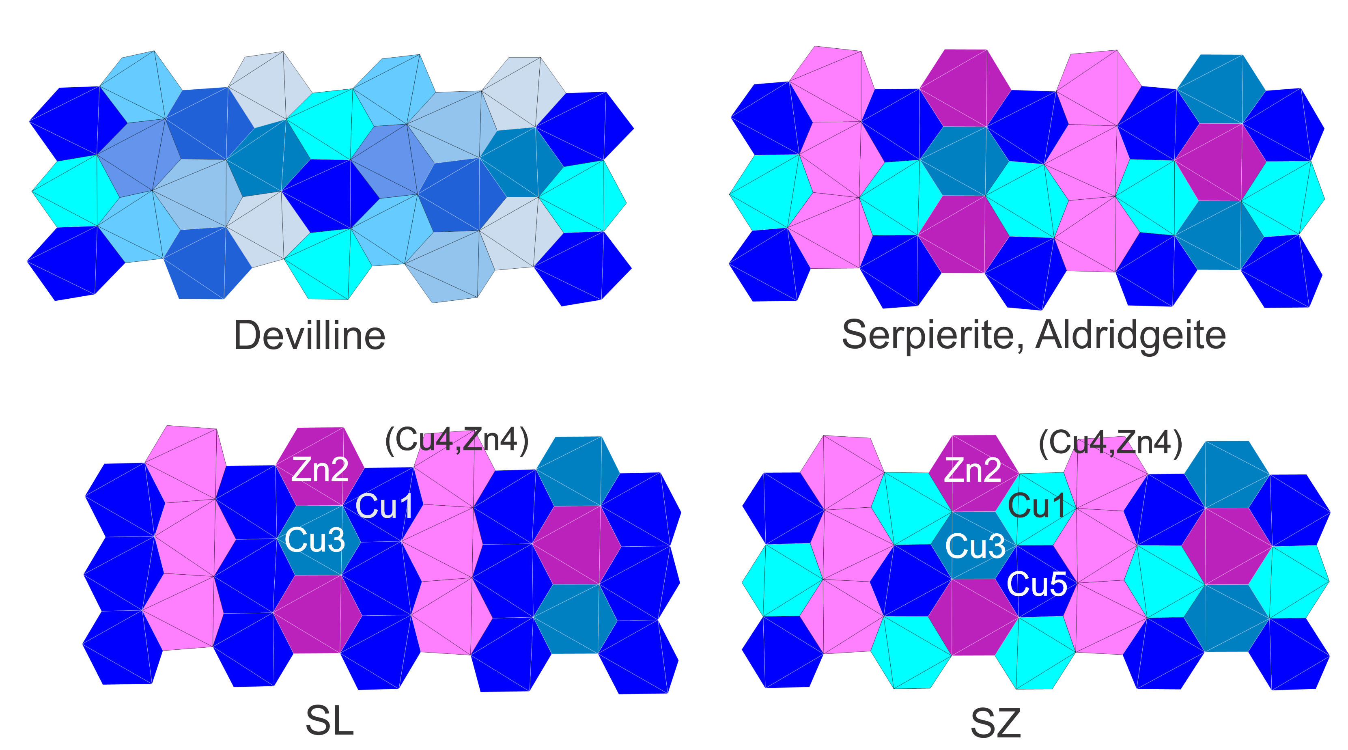

**Fig. S1** Octahedral layers of the minerals with “serpierite topology”. The symmetrically equivalent positions are marked with the same color.

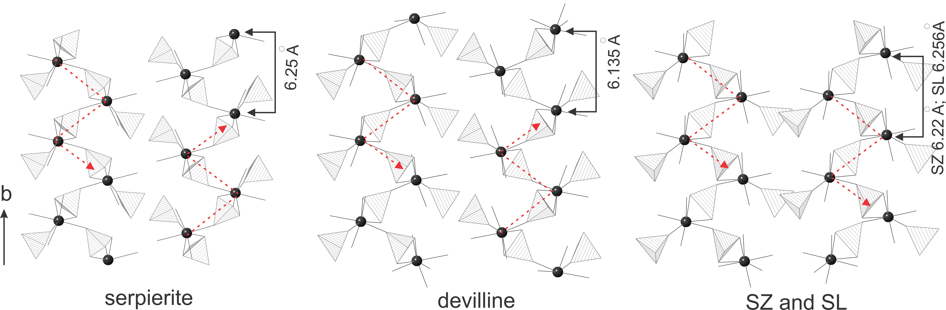

**Fig. S2** The adjacent 1∞[(Ca,Cd)2(SO4)3] units connecting the octahedral layers of the minerals with “serpierite topology” .